To evaluate an if expression:

* 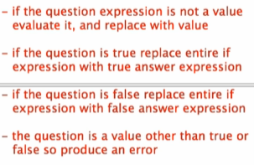

Modifying our if expression:





 -> 





    